AVERAGES
Pearson Edexcel - Sample Paper 1 - (Non-Calculator) Higher Tier
1.
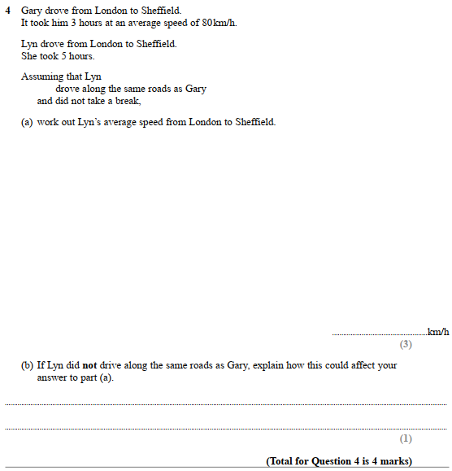

Pearson Edexcel - Friday 6 November 2015 - Paper 2 (Calculator) Higher Tier
2.
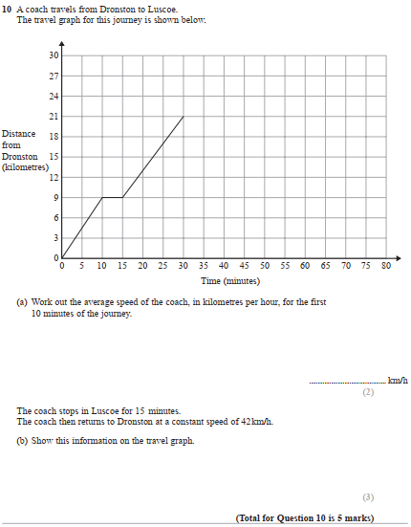

Pearson Edexcel - Thursday 4 June 2015 - Paper 1 (Non-Calculator) Higher Tier
3.
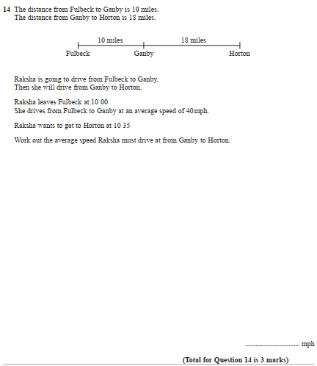

Pearson Edexcel - Friday 7 November 2014 - Paper 2 (Calculator) Higher Tier
4.
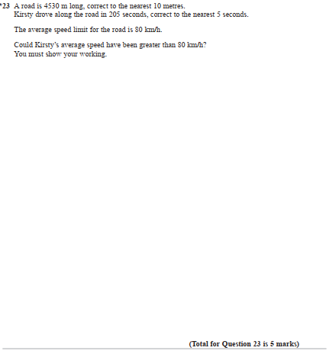

Pearson Edexcel - Monday 9 June 2014 - Paper 1 (Non-Calculator) Higher Tier
5.
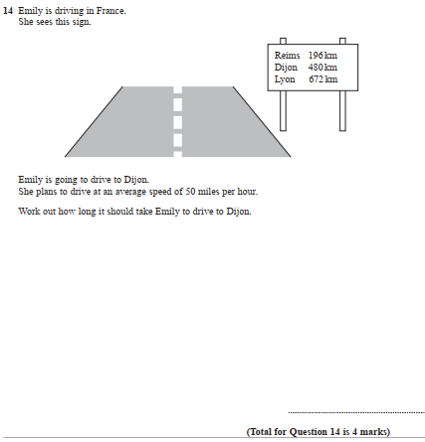

Pearson Edexcel - Tuesday 11 June 2013 - Paper 1 (Non-Calculator) Higher Tier
6.
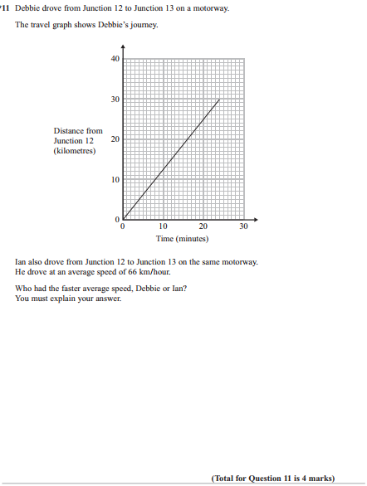

Pearson Edexcel - Monday 4 March 2013 - Paper 2 (Calculator) Higher Tier
7.
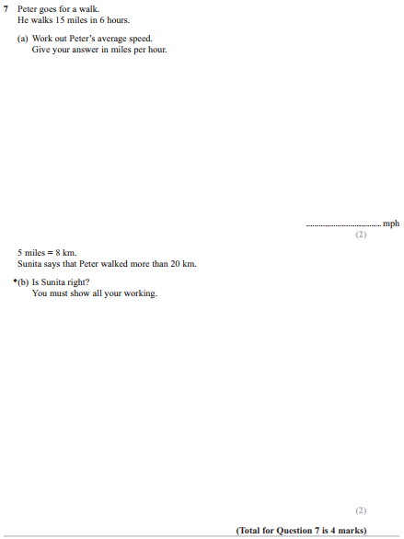

Pearson Edexcel - Friday 12 November 2010 - Paper 4 (Calculator) Higher Tier
8.
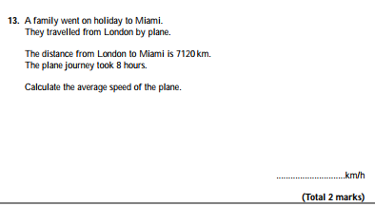
OCR GSCE – Tuesday 12 June 2018 – Paper 6 (Calculator) Higher Tier
9.
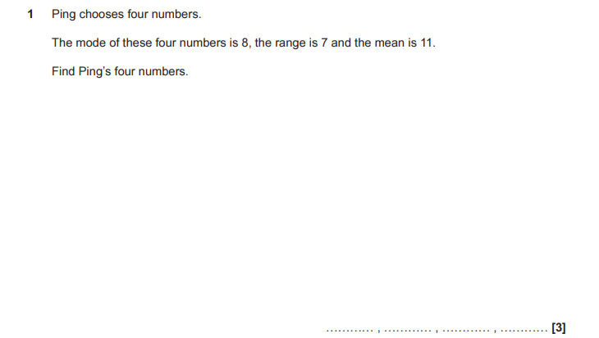

OCR GSCE – Thursday 8 June 2017 – Paper 5 (Non - Calculator) Higher Tier
10.
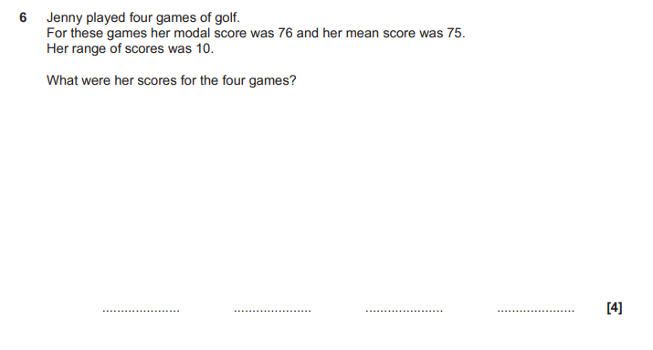

AQA GSCE – Thursday 8 June 2020 – Paper 3 (Calculator) Higher Tier
11.
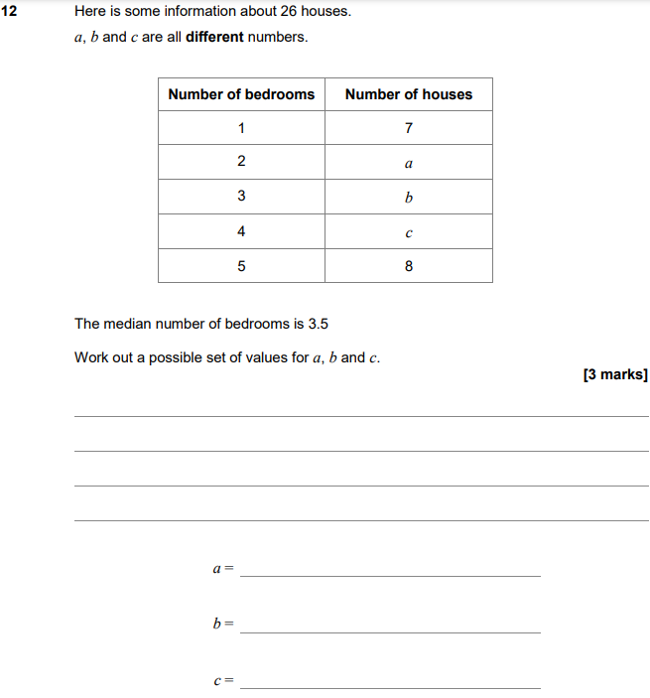

AQA GSCE – Monday 12 November 2018 – Paper 3 (Calculator) Higher Tier
12.
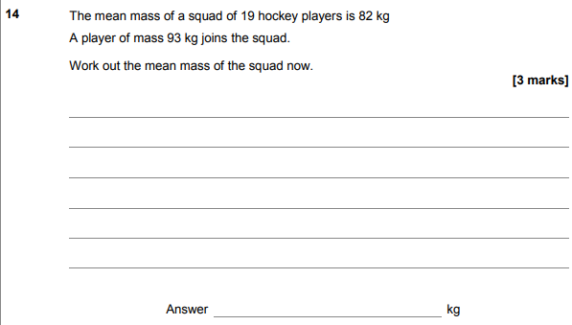
AQA GSCE – Monday 24 May 2018 – Paper 1 (Non - Calculator) Higher Tier
13.
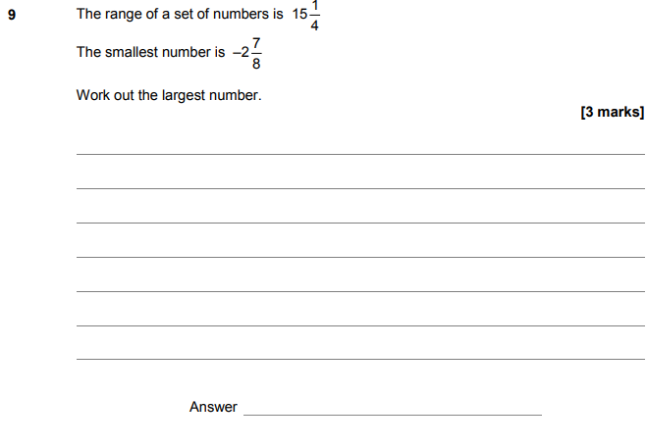

AQA GSCE – Thursday 7 June 2018 – Paper 2 (Calculator) Higher Tier
14.
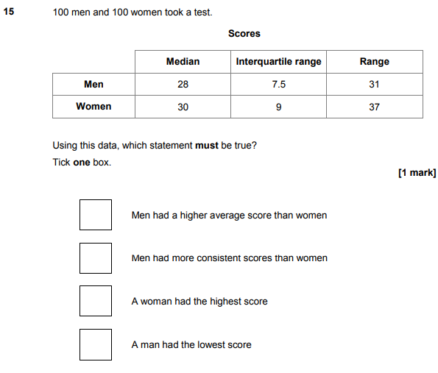

AQA GSCE – Thursday 2 November 2017 – Paper 1 (Non - Calculator) Higher Tier
15.
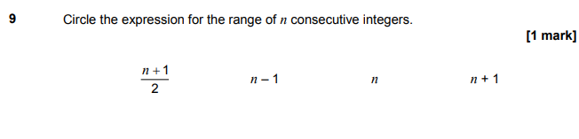
AQA GSCE – Thursday 2 November 2017 – Paper 1 (Non - Calculator) Higher Tier
16.
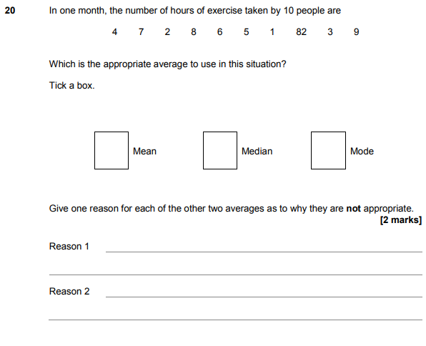

AQA GSCE – Thursday 6 November 2017 – Paper 2 (Calculator) Higher Tier
17.
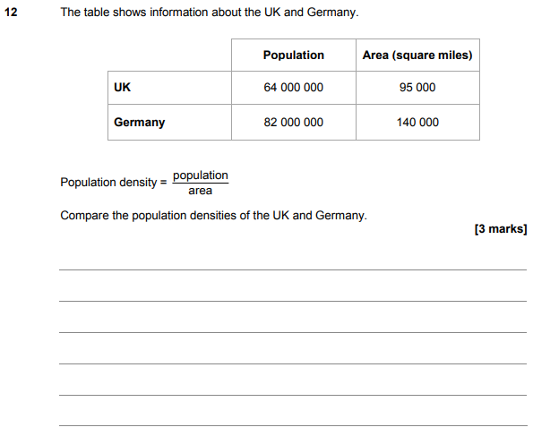

AQA GSCE – Tuesday 13 June 2017 – Paper 3 (Calculator) Higher Tier
18.
